CSA0501-DATABASE MANAGEMENT SYSTEMS
LAB EXPERIMENTS DATE: 14-07-2026

EXPERIMENT 6 - SELECT with various clause – BETWEEN, IN, Aggregate function

AIM:
To view the records from the tables using SELECT commands with BETWEEN, IN, Aggregate functions.

PROCEDURE:
- Open MySQL Workbench and connect to the database.
- Select the required database using the USE command.
- Execute the SELECT statement with the BETWEEN operator to retrieve records within a range.
- Execute the SELECT statement with the IN operator to retrieve records matching a list of values.
- Use aggregate functions (COUNT, SUM, AVG, MIN, MAX) to perform calculations.
- Verify the output.

PROGRAM:

1. List the domains IN "Python Developer" and "AI Intern"

SELECT InternName, Domain
FROM INTERN
WHERE Domain IN ('Python Developer', 'AI Intern');

OUTPUT:
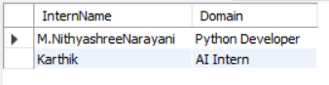

2. Display faculty whose age is between 40 and 60
SELECT *
FROM FACULTY
WHERE Age BETWEEN 40 AND 60;
OUTPUT:
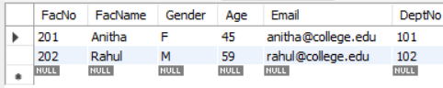

3. Display Faculty whose Age is less than 60
SELECT *
FROM FACULTY
WHERE Age < 60;
SELECT * FROM FACULTY;
OUTPUT:
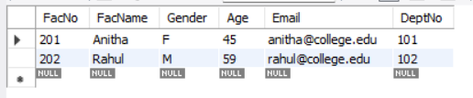

Aggreagate functions
4. Find the average age of faculty

SELECT AVG(Age) AS Average_Age
FROM FACULTY;
OUTPUT:
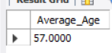

5.Find the maximum and minimum age of faculty
SELECT MAX(Age) AS Maximum_Age,
MIN(Age) AS Minimum_Age
FROM FACULTY;
OUTPUT:
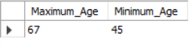

6. Calculate the sum of all faculty ages
SELECT SUM(Age) AS Total_Age
FROM FACULTY;
OUTPUT:
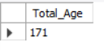

7. Display each department and the number of faculty members
SELECT D.DeptName,
COUNT(F.FacNo) AS Number_of_Faculty
FROM DEPARTMENT D
LEFT JOIN FACULTY F
ON D.DeptNo = F.DeptNo
GROUP BY D.DeptName;
OUTPUT:
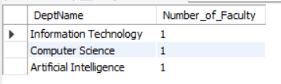

RESULT:

The BETWEEN, IN, and Aggregate Functions (AVG, COUNT, SUM, MIN, and MAX) were successfully executed to retrieve and summarize data from the tables..

